Purdue University

Department of Economics

**ECON 370 International Trade, Summer 2018**

**Final Exam**

**First Name: ____________________________________________________________**

**Last Name: ____________________________________________________________**

**PUID: ___**______________________________________________________________

**DO NOT WRITE IN THE AREA BELOW:**

Section 1: _ _ _ _/30

Section 2: _ _ _ _/20

Section 3: _ _ _ _/30

Section 4: _ _ _ _/20

Total: _ _ _ _/100

**Instructions. Please read carefully.**

Write your answer in the space provided between questions. Use the blank page for scratch work.

While submitting the exam attach your cheat sheet.

Good Luck!

**Section 1. Very Short Answers**   **(30 Points)**

Multiple choice questions (28 Points)

* 1. Reason for the resurgence of trade in the Second golden age of trade:

1. Improvement of transportation
2. Reduction of tariff
3. End of world war
4. All of the above

Answer:

* 1. A Vietnamese student takes admission at Purdue University is an example of _________________________ of the US and ____________ of Vietnam.

1. service export, service import
2. service import, service export
3. goods import, goods export
4. goods export, goods import

Answer:

Consider the following table for answering questions 1.3. - 1.5.

MPL Labor Endowments

Pens Pencils

France 1/10 1/15 90

Germany 1/12 1/20 120

* 1. In the given table, if the labor supply in France goes up from 90 to 150, then:

1. France will have absolute advantage in both pens and pencils
2. France will have comparative advantage in both pens and pencils
3. France will have absolute disadvantage in pens
4. France will have absolute disadvantage in pencils

Answer:

* 1. Under free trade, the world output of pen equals 10 units.

1. True
2. False
3. Uncertain
4. Don’t have enough information

Answer:

* 1. Under free trade, the relative relative price of pens to pencils (PpensFT/PpencilsFT) cannot exceed 2/3.

1. True
2. False
3. Uncertain
4. Don’t have enough information

Answer:

* 1. According to ____________________: “An increase in the amount of a factor found in an economy will increase the output of the industry using that factor intensively, and decrease the output of the other industry.”

1. Hecksher-Ohlin Theorem
2. Stolper-Samuelson Theorem
3. Rybczynski Theorem
4. Leontief Paradox

Answer:

* 1. Home, a small, open economy, uses a mobile factor (labor) and two specific factors (drylands and wetlands) to produce two goods, cactus and rice. Dryland is only productive in growing cactus and wetlands can only grow rice. Suppose that the world price of cactus is lower than Home’s no-trade price but its no-trade price of rice is lower than the world price.

1. By engaging in trade, the wetland owners would be worse off
2. By engaging in trade, the dryland owners would be worse off
3. By engaging in trade, both the dryland owners and the wetland owners would be worse off
4. By engaging in trade, both the dryland owners and the wetland owners would be better off

Answer:

For answering 1.8 and 1.9, refer to Fig 1.

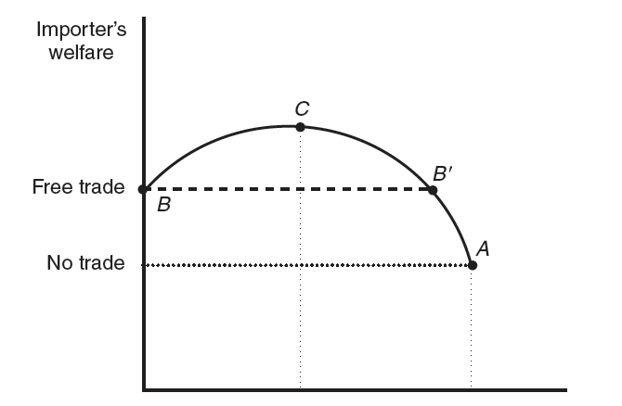

Tariff

Fig. 1

* 1. In Fig 1., in the region to the left of point C:

1. TOT gain > Deadweight loss
2. TOT gain = Deadweight loss
3. TOT gain < Deadweight loss
4. None of the above

Answer:

* 1. In Fig 1., in the region to the right of point C:

1. TOT gain > Deadweight loss
2. TOT gain = Deadweight loss
3. TOT gain < Deadweight loss
4. None of the above

Answer:

To answer questions 1.10. and 1.11., refer to Fig 2.

Suppose Home imports some goods from Foreign. Fig 2. illustrates the export supply curve of Foreign.

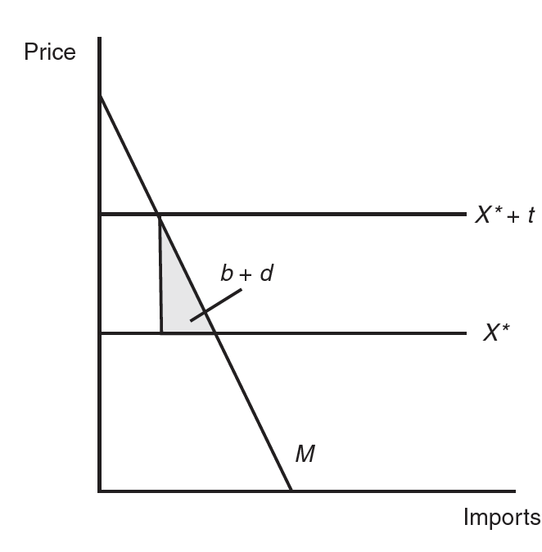

Fig 2.

* 1. Home is a _________ open economy and Foreign is a ____________ open economy.

1. Can’t determine, Small
2. Can’t determine, Large
3. Small, Can’t determine
4. Large, Can’t determine

Answer:

* 1. The optimal tariff charged by Home is:

1. -1
2. 0
3. 1
4. Infinity

Answer:

Consider the following payoff matrix to answer questions 1.12 -1.14

**Airbus**

**Produce Not Produce**

**Produce**

**Boeing** -35, -35 80, 0

**Not Produce** 0, 80 0 , 0

Solving this game, we get two Nash Equilibria. Suppose in the free trade, the economy is operating at (Produce, Not Produce)

* 1. The government of Europe gives subsidy of 20 to Airbus. Now, the Nash equilibrium is:

1. (Produce, Produce)
2. (Not Produce, Not Produce)
3. (Produce, Not Produce)
4. (Not Produce, Produce)

Answer:

* 1. In the post subsidy situation, the producers in the US are:

1. Gaining
2. Losing
3. Not affected
4. Can’t determine welfare effects for the US producers

Answer:

* 1. The US government also starts providing subsidy of 10 to Boeing. After this policy change, the producers in Europe are:

1. Gaining
2. Losing
3. Not affected
4. Can’t determine welfare effects for European producers

Answer:

**Based on your project (2 Points)**

* 1. Were the findings of your project consistent with what you learned in class? If yes, how? If not, how? Briefly explain.

Answer:

**Section 2. Short Answers (20 Points)**

2.1. State four differences of the Specific Factor Model and the Ricardian Model.

Answer:

Ricardo Model SFM

1.

2.

3.

4.

2.2. Suppose Ireland and Canada produce two goods, Y and X. Assume that good Y is labor intensive and

good X is capital intensive.

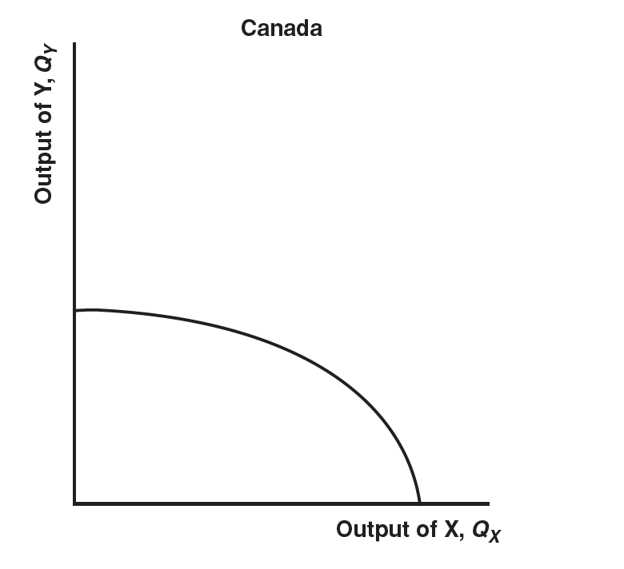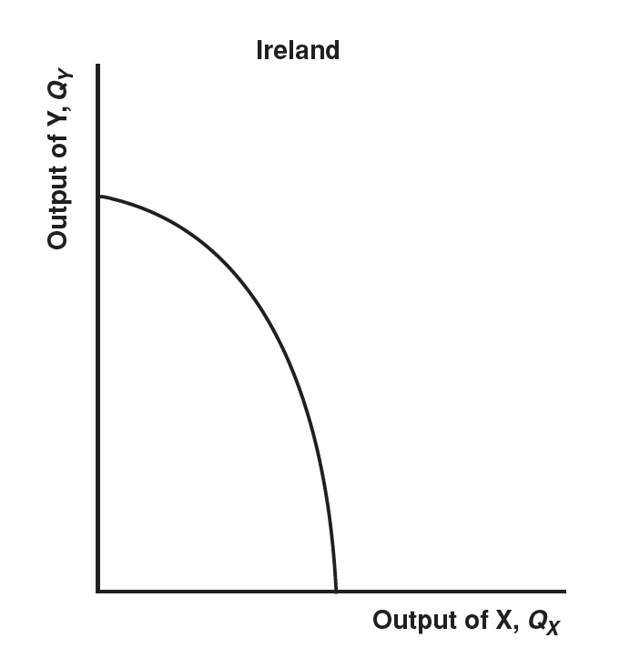

Given the above PPFs, which country is relatively labor-abundant? Capital-abundant? Explain.

Answer:

2.3. Based on economic intuition (that is, not using graph), compare the Home welfare in the following situations. Consider the markets to be perfectly competitive.

1. Quota with the imports of M in a small country with quota licenses distributed to Home firms and no rent seeking.
2. Quota of M in a small country with the quota given to the exporting Foreign firms.
3. Quota of M in a small country with the quota licenses auctioned to Home firms.
4. Quota of M in a small country with quota licenses distributed to rent-seeking Home firms.

Answer:

2.4.

Determine the net impact on Home’s welfare when it imposes a tariff of $2 on the Foreign monopolist

using the following figure.

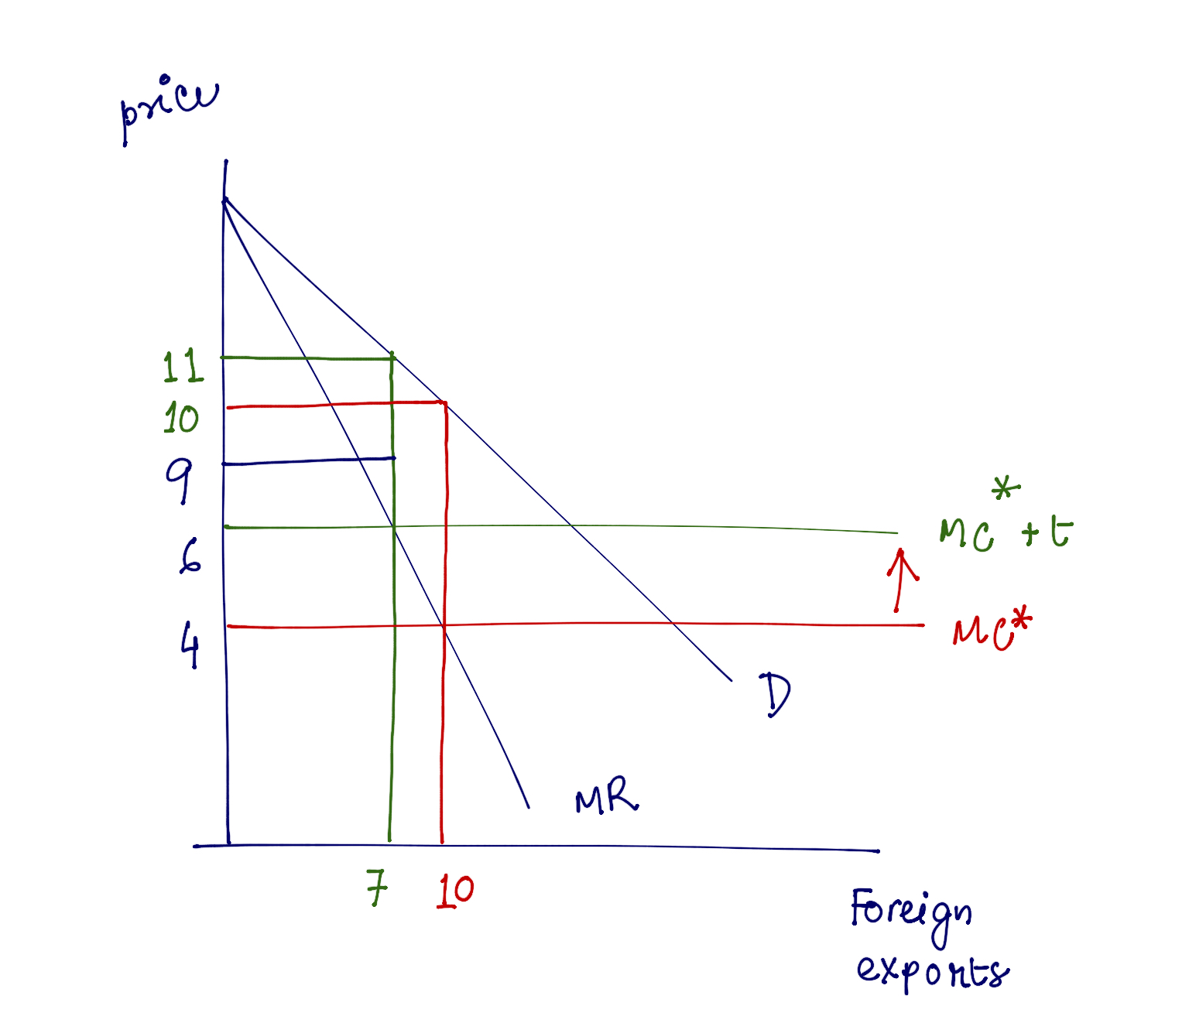

Answer:

Change in Home consumer surplus:

Change in Home government revenue:

Net change in Home welfare:

**Section 3. Numerical Problems (30 Points)**

3.1. Suppose the payments to labor and capital in Computers and Shoes are given by the following:

**Computers:**

Sales revenue =PC * QC = $100

Payments to labor = W * LC =$50

Payments to capital = R * KC = $50

**Shoes:**

Sales revenue = PS * QS = $100

Payments to labor = W * LS = $5

Payments to land = R * KS = $95

Suppose, under free trade, the following price changes:

Computers: Percentage increase in price = ΔPC / PC = 0%

Shoes: Percentage increase in price = ΔPS / PS = 50%

1. Which industry is labor intensive? Which industry is capital intensive? (5 Points)
2. Given the percentage changes in output prices, calculate the percentage change in rental on capital for each sector. (5 Points)
3. How does the magnitude of this change compare with that of labor? (5 Points)

3.2

Suppose Home is a **small exporter** of wheat. At the world price of $100 per ton, Home exports 20 tons. Now suppose the Home government decides to support its domestic producer with an export subsidy of $40 per ton. Use the following figure to answer part a and b.

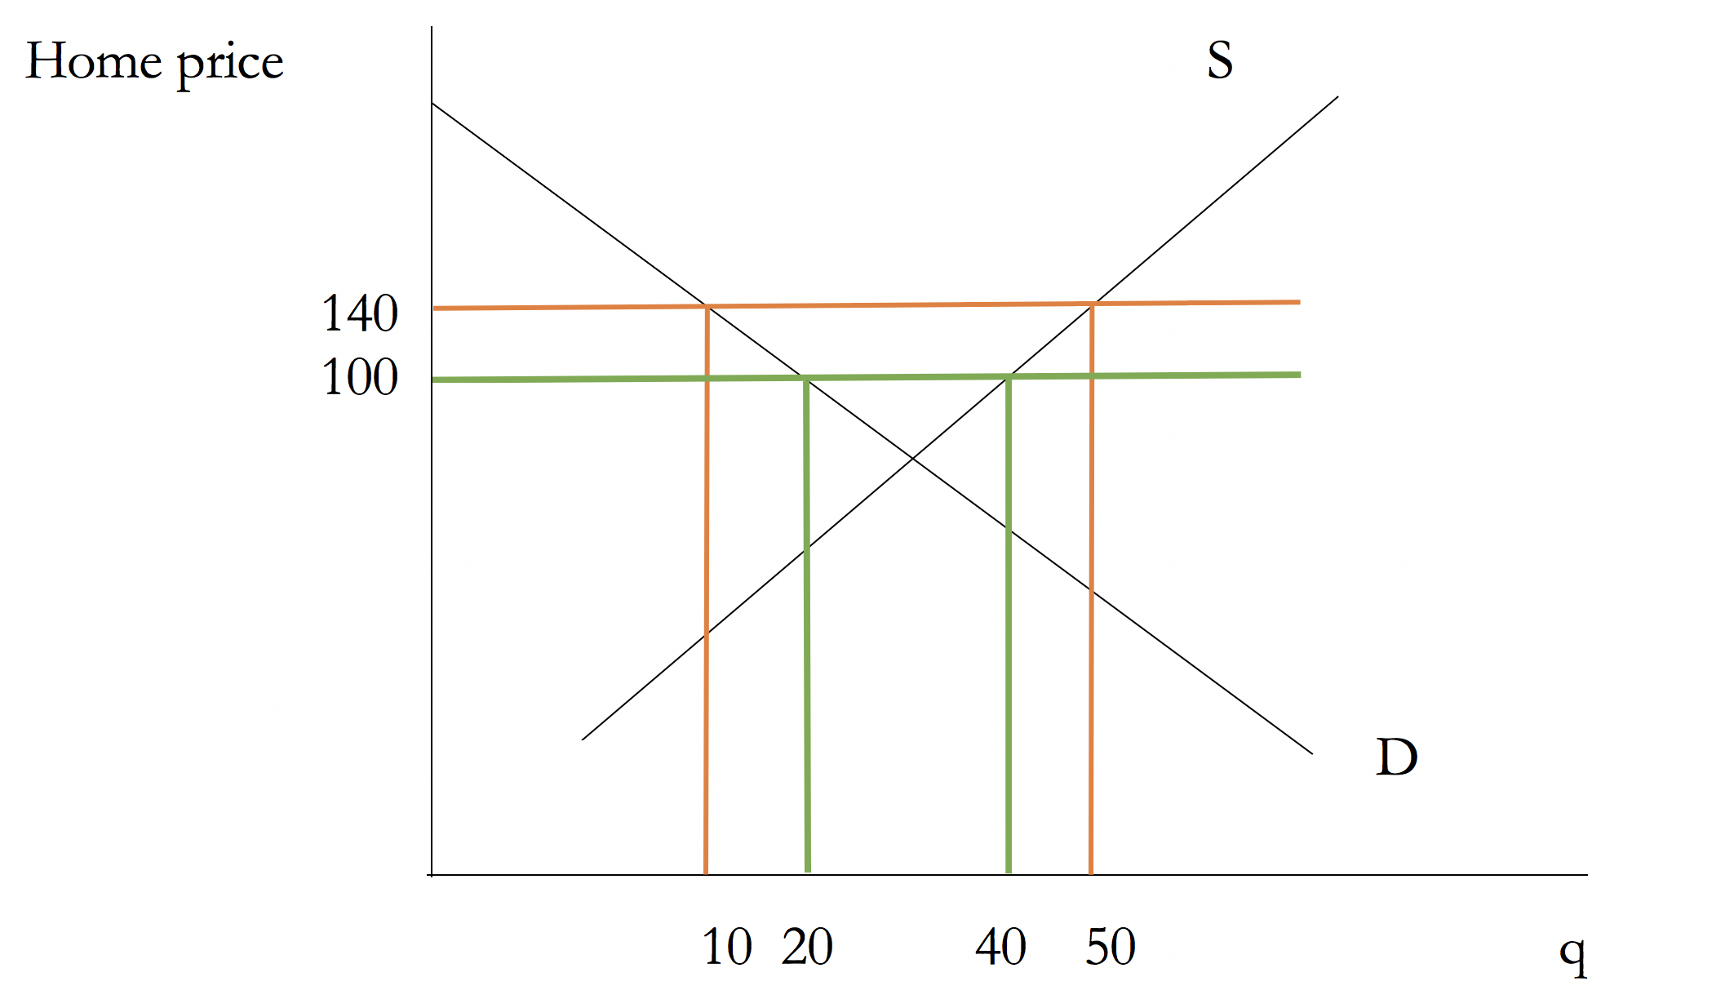

1. What are the quantity exported under free trade and with the export subsidy? (2 Points)
2. Calculate the effects of export subsidy on consumer surplus, producer surplus and government revenue. (5 Points)

Now suppose, Home is a **large country.** An export subsidy of $40 per ton increases the local price to $120 while the foreign market price declines to $80 per ton. Use the following figure to answer part c, d and e.

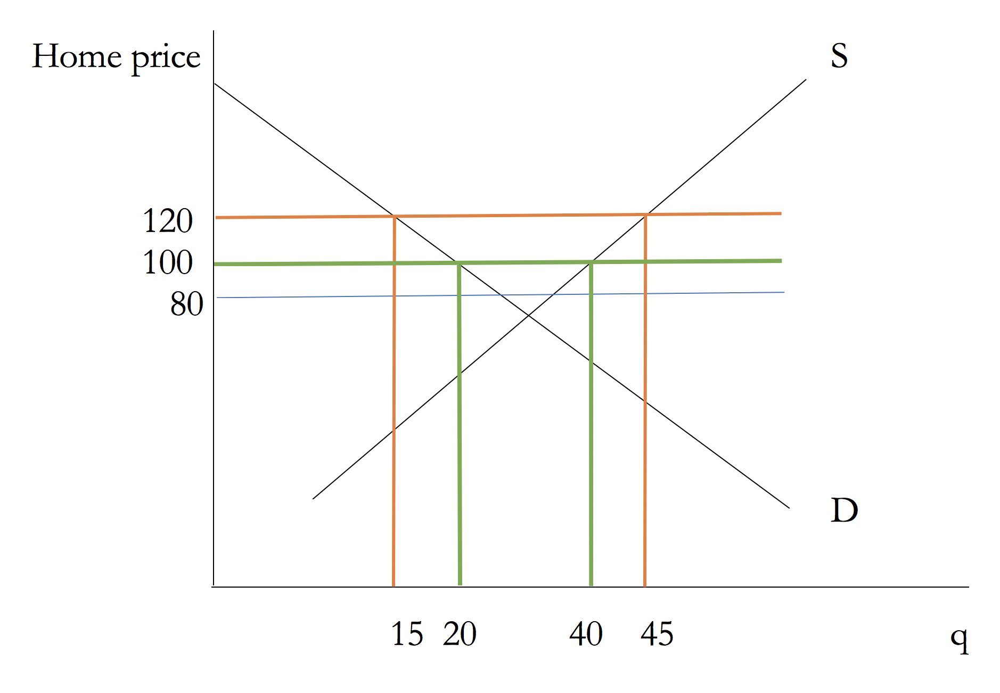

1. Relative to the small country case, why does the new domestic price increase by less than the amount of subsidy? (1 Point)
2. Calculate the effects of export subsidy on consumer surplus, producer surplus and government revenue. (5 Points)
3. Is the large country better off or worse off as compared to the small country with the export subsidy?

(2 Points)

**Section 4. Conceptual Questions with Long Answers (20 Points)**

4.1. (10 points)

Recall the “Mariel Boatlift Puzzle” we talked about in class.

“During May and September, 1980, 125,000 Cubans left the port of Mariel, Cuba, for Miami, which increased the host city’s population by about 7%. Despite the large supply of low-skilled immigrants from Cuba, the wages of low-skilled workers in Miami did not vary much relative to the national trend.”

Which model solves this puzzle? Using an appropriate graph, explain how this model solves the puzzle.

**OR**

Which model fails to solve this puzzle? Using an appropriate graph, explain why this model set up is not able to solve the puzzle.

4.2.

Suppose Home is a **small open economy**. Foreign firm is a **monopolist** and Foreign practices dumping on Home. To protect the domestic producers at Home, the Home government imposes an **anti-dumping duty** (tariff) of t on imports from Foreign.

1. Using appropriate graphs, explain the effects of anti-dumping duty on consumer surplus, producer surplus and government revenue at Home. (5 Points)

(Label the axis, the lines, the points and the areas relevant for your explanation. **Graph both the home market and the world market**, however use home market graph to show the welfare effects.)

1. Suppose that in response to a threated anti-dumping duty of t, the Foreign Monopoly raises its price by the amount t. How the effects on consumer surplus, producer surplus and government revenue at Home change? Explain using the graphs you have drawn in part a. (5 Points)

**OR**

1. Consider that Home is a **small open economy**. Consider the markets to perfectly competitive. Using appropriate graph explain the welfare effects on the consumers, producers and the government of the Home economy if the government of Home imposes an import tariff of $ t per unit of imports.

(Clearly label the axis, the lines, the points and the areas relevant for your explanation. Graph only the home market to show the welfare effects.) (4 Points)

1. Now suppose, the home government raises tariff from t to tNEW such that **tNEW is a prohibitive tariff.** **Redraw the graph** and show how the welfare effects on the consumers, producers and the government of the Home economy change due to this tariff increase. (6 Points)

(Clearly label the axis, the lines, the points and the areas relevant for your explanation. Graph both the home market and the world market, however use home market graph to show the welfare effects.)

BLANK PAGE